Nepal College of Information Technology
Assessment-2009

Program: BE Time: 3 hrs
Semester: Spring FM: 100
Subject: Applied Mechanics PM: 50
Attempt all the questions.
1. a) A homogeneous metal cylinder weighing 700 N is supported by a flexible cable and a smooth inclined plane as shown. Determine the tension in the cable and the force exerted by the inclined plane on the cylinder. [7]
.
45º
60º

OR
Determine the magnitude of force F so that the resultant F_{R} of the three forces is as small as possible. What is the magnitude of F_{R} ? [7]

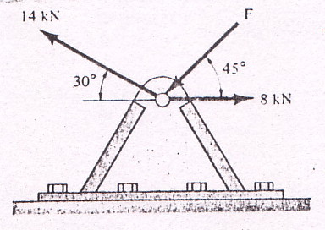
b) Determine the magnitude of the moment of each of the three forces about the axis AB. [8]
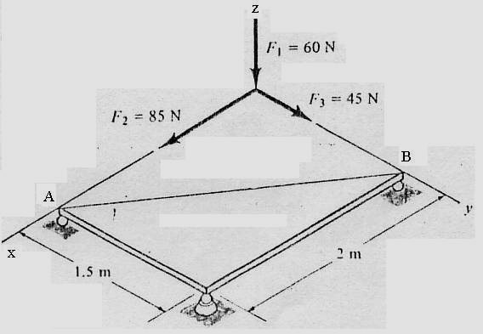

2. a) Determine the smallest force P for which equilibrium of the 7.5 kg block is maintained. [8]
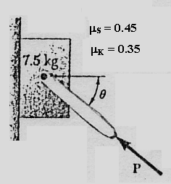
b) Determine by direct integration the moment of inertia of the shaded area with respect to the x axis and y axis respectively. [7]
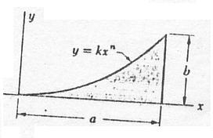

3. a) The acceleration of a particle is defined by the relation a = - kv³, where a is expressed in m/s² and v in m/s. The particle starts at x = 0 with a velocity of 25 m/s and when x = 40 m the velocity is found to be 20 m/s. Determine the distance particle will travel
i) before its velocity drops to 10 m/s,
ii) Before it comes to rest. [7]

b) A rocket is fired vertically from a lunching pad at B. Its flight is tracked by radar from point A. Determine the velocity and acceleration of the rocket at the instant when 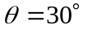 and the radar tracking device is turning at 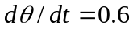 rad/sec and 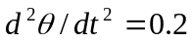 rad/sec²; b = 800m. [8]

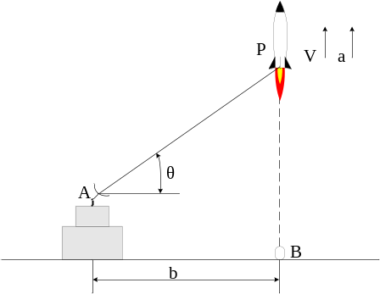

4. The two blocks shown are originally at rest. Neglecting the masses of the pulleys and the effect of friction in the pulleys and between block A the incline. Determine
a.) the acceleration of each block
b.) the tension in the [15]

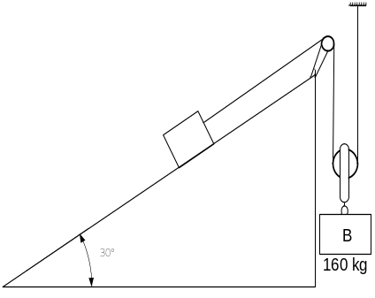
5. A 100 N body moves along the two inclines for which the coefficient of friction is 0.3. If the body starts from rest at A and slides 200 ft. down the 30° incline, how far will it then move along the other incline? What will be its velocity when it returns to B? [15]

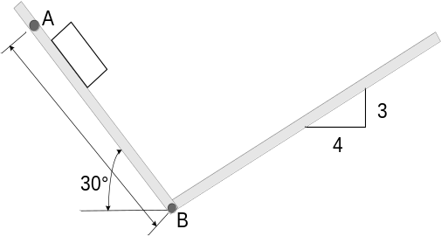
6. A ballistic pendulum consists of a sand box weighing 5 kg that is suspended from a cord 3 m long. A 50 g shell is fired horizontally in the box and remains embedded in it. Because of impact, the sand box swings through a maximum angle 30°, as shown. Determine the velocity with which the shell strikes the box and loss in energy of the system. [15]

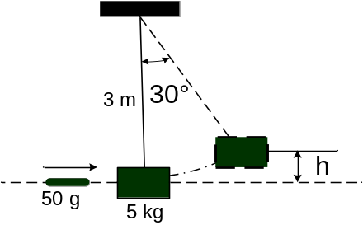
7. Write short notes on(any two) [2*5=10]
a) Parallel axis theorem
b) Principle of work and energy
c) Direct centre impact

